Page 1
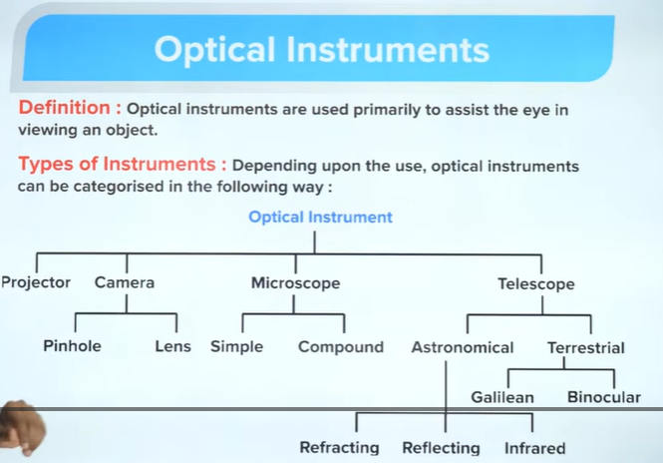

The above image is just a reference. This page should have a transition effect where only the Microscope in the types of optical instruments zooms in to the screen along with its sub types Simple and Compound thus resulting to page 2

Page 2
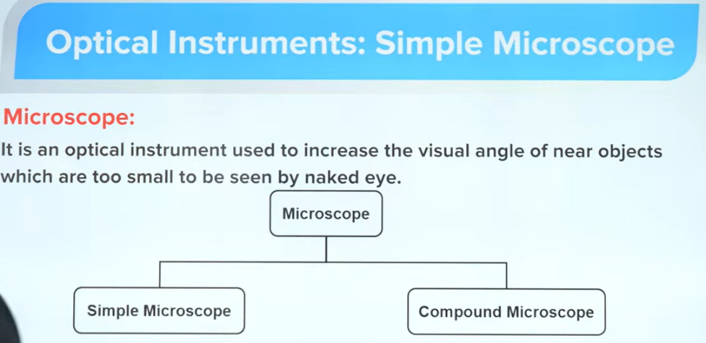
The word ‘visual angle’ would be highlighted and underlined, when it is touched it redirects to page 5

Page 3
CAN ONLY OPTICAL INSTRUMENTS BE USED TO MAGNIFY AN OBJECT?
2d visual: A car coming forward, which slowly appears to increase in size; the distance between the viewer and the object is reducing

Page 4
Then why do we use optical instruments?

2d visual: a side view of a viewer who is bringing an object closer to him; after a point, it may appear blurry and appear to be more than one, and his eyes will strain
This page will have a small button in the left bottom corner which is not merely visible from distant, this will redirect to page 2

Page 5
VISUAL ANGLE: It is the angle subtended by the object on the eye
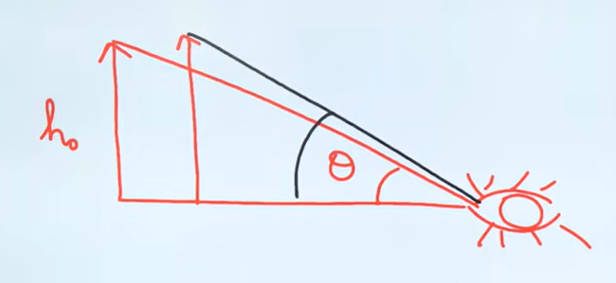
The above diagram is a very rough diagram.
Interactive visual needed: take the diagram as reference and create an interactive visual in which I can move the object closer to the viewer, replace eye with a viewer, when I move the object then the diagram changes smoothly helping the audience to easily visualize the diagram, after trying to move the object further closer more than a extent, then the object should look blurry and twice in the screen which would help the audience visualize least distance of distinct vision, similarly the decrease of the distance between them should also be shown, the change in the angle should also be shown

(This definition comes after a transition)
definition in separate closed box:
The least distance from the eye at which an object can be seen clearly and distinctly without strain is called the least distance of distinct vision.

Page 6
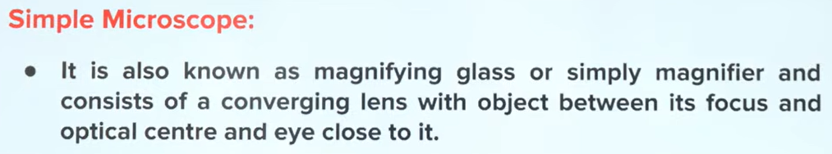
The word ‘converging’ should be highlighted and underlined; when clicked on it, the word will automatically change to ‘convex’ and vice versa
A gif like repeating visual needed: a magnifying glass and a text ‘ABC123’, the glass moves right on the text, and the text through the glass looks enlarged.

Page 7
Different cases of a convex lens
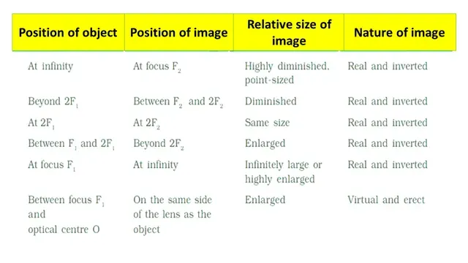
The above table should be replicated and presented neatly. The last row is highlighted and outlined by a border, this last row alone looks a little enlarged, showing its highlight

Page 8
Working of a Simple Microscope by ray diagram :-
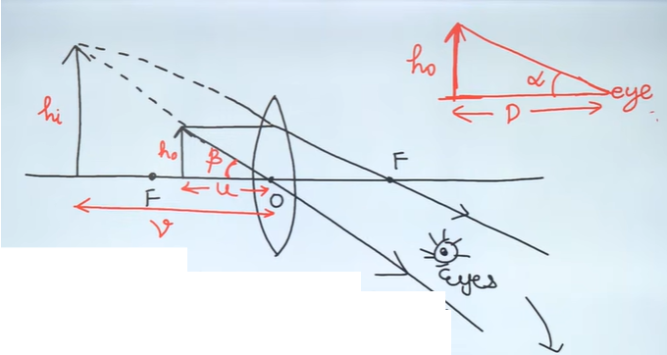
Interactive Visual: The above diagram is rough, and I want it to be reproduced perfectly. Also, the image properties should be highlighted in a box (Virtual, Erect, and Enlarged)
The object can be moved only between F and O, which will respectively change the diagram smoothly.
Also there is an another diagram on the right top corner, both diagrams have to be in the left and right, the red inked diagram from the image should be reproduced and should be interactive by moving the object. Both the diagrams should have the eye
Below these 2 diagrams, there is a derivation for magnification
This part appears only after clicking the transition button in the bottom-right corner above the next page button. This transition button is only present for selected pages that have transitions
Now I will give the derivation step by step for each transition
Heading: Angular Magnification
The ratio of the angle subtended at the eye by the image formed by an optical instrument to that subtended at the eye by the object when not viewed through the instrument.
m = Visual angle subtended by image on eye / Visual angle subtended by object when kept at D
= Beta/Alpha
tan Beta = ho / -u
for small angles tan teta similar to teta
Beta = ho / -u
tan Alpha = ho / -D
Alpha = ho / -D
m = Beta/Alpha = (ho / u) / (ho / D) = D / u

Page 9
Visual: visual diagram with visual angle for maximum angular magnification
Case 1: Image Formed at the Near Point
$$\frac{1}{v}-\frac{1}{u}=\frac{1}{f}$$
• $v=-D$
• $u=-u$
• $f=+f$ (convex lens)
$$\frac{1}{-D}-\frac{1}{-u}=\frac{1}{f}$$
$$-\frac{1}{D}+\frac{1}{u}=\frac{1}{f}$$
$$\frac{1}{u}=\frac{1}{f}+\frac{1}{D}$$
Multiply throughout by $D$:
$$\frac{D}{u}=\frac{D}{f}+\frac{D}{D}$$
$$\frac{D}{u}=1+\frac{D}{f}$$
Since $m=\frac{D}{u}$:
$$m_{\text{max}}=1+\frac{D}{f}$$

Page 10
Visual: visual diagram with visual angle for minimum angular magnification
Case 2: Image Formed at Infinity
(Normal Adjustment / Relaxed Eye)
$$v=-∞$$
Object distance $=-u$
Focal length $=+f$ (converging / convex lens)
$$\frac{1}{v}-\frac{1}{u}=\frac{1}{f}$$
$$\frac{1}{-∞}-\frac{1}{-u}=\frac{1}{f}$$
Since $\frac{1}{∞}=0$:
$$0+\frac{1}{u}=\frac{1}{f}$$
$$\frac{1}{u}=\frac{1}{f}$$
u = f
m = D / f

v / u = -D / -u = D / u
Linear magnification = Angular magnification

The following should be in an enclosed box
‘A simple microscope has a limited maximum magnification ($≤$ 9) for realistic focal lengths’
Interactive Visual: a visual of an object on the left and a magnifying glass in the right, and to the left of both there is text ‘1X’, when the magnifying glass is placed on the object, then the text should change to ‘9X’.
The magnifying glass can be moved to only these 2 positions

